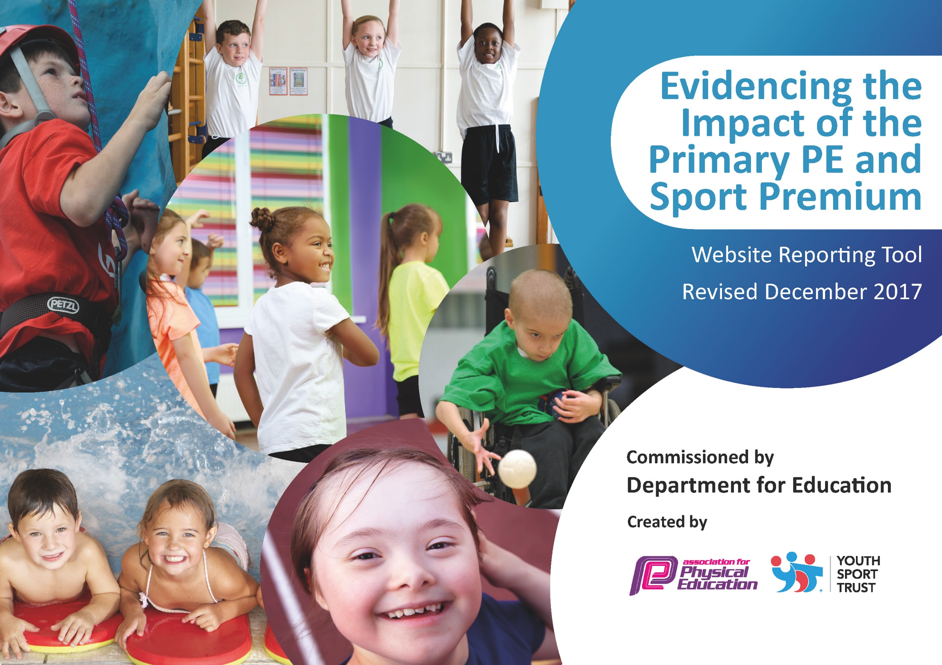
Schools must use the funding to make additional and sustainable improvements to the quality of PE and sport they offer. This means that you should use the Primary PE and Sport Premium to:

- develop or add to the PE and sport activities that your school already offers
- build capacity and capability within the school to ensure that improvements made now will benefit pupils joining the school in future years

Please visit gov.uk for the revised DfE guidance including the 5 key indicators across which schools should demonstrate an improvement. This document will help you to review your provision and to report your spend. DfE encourages schools to use this template as an effective way of meeting the reporting requirements of the Primary PE and Sport Premium.

We recommend you start by reflecting on the impact of current provision and reviewing the previous spend.
Under the Ofsted Schools Inspection Framework, inspectors will assess how effectively leaders use
the Primary PE and Sport Premium and measure its impact on outcomes for pupils, and how effectively governors hold them to account
for this.

Schools are required to publish details of how they spend this funding as well as on the impact it has on pupils’ PE
and sport participation and attainment.
We recommend regularly updating the table and
publishing it on your website as evidence
of your ongoing review into how you are using the money
to secure maximum, sustainable impact. To see an example of how to complete the table please click HERE.

Support for review and reflection - considering the 5 key indicators from DfE, what development needs are a priority for your setting and your students now and why? Use the space below to reflect on previous spend, identify current need and priorities for the future.
Key achievements to date: | Areas for further improvement and baseline evidence of need:
In relation to key indicator 1: We have strived to make any ‘spare’ time throughout the day as active as possible – we have spent a lot of money on equipment for break times and lunch times that is accessible to all children, to give them more opportunity and make them more active – more through choice than just through P.E  In relation to key indicator 3: We have spent money on a new PE scheme which will support all staff in their knowledge and delivery of PE  In relation to key indicator 4: We have spent money on creating opportunities for most children to have a broader range of sports they experience.  In relation to key indicator 5: More children this year have had a chance to participate in competitive sport, using the premium to make this achievable  I feel all of these achievements feed through to key indicator 2. | We have a carry forward left from the previous year that I had wanted to spend of training on ‘Active Maths’, although I did contact them I did not receive a reply so this will be one of my main priorities for next year.  Looking forward we still need to put more training for teachers on how to effectively deliver their lessons – they have the new scheme to work from but how best to deliver will be target to improve for the year ahead.  Money will also be used the next year to implement more opportunity for Y6 to work on their swimming confidence and skill.  Support from SGO’s to train PE leaders/Play leaders for the year ahead.

Meeting national curriculum requirements for swimming and water safety | Please complete all of the below*:
What percentage of your current Year 6 cohort swim competently, confidently and proficiently over a distance of at least 25 metres? | 87%
What percentage of your current Year 6 cohort use a range of strokes effectively [for example, front crawl, backstroke and breaststroke]? | 65%
What percentage of your current Year 6 cohort perform safe self-rescue in different water-based situations? | 77%
Schools can choose to use the Primary PE and Sport Premium to provide additional provision for swimming but this must be for activity over and above the national curriculum requirements. Have you used it in this way? | No

Action Plan and Budget Tracking

Academic Year: 2018/19 | Total fund allocated: 17, 370 | Date Updated: 28.7.19
Key indicator 1: The engagement of all pupils in regular physical activity – Chief Medical Officer guidelines recommend that primary school children undertake at least 30 minutes of physical activity a day in school |  |  |  | Percentage of total allocation:
 |  |  |  | 8.8%
School focus with clarity on intended impact on pupils: | Actions to achieve: | Funding allocated: | Evidence and impact: | Sustainability and suggested next steps:
We looked at the school timetable and saw opportunity for children to be more active at playtimes if they were provided with specific equipment for active play. | Research different playtime equipment that will support active playtimes.  Run assembly on equipment and how best can it be used for active play. | 1,521 | All children have used the equipment as intended and they are 90% more active over playtimes – there is more play together too. The equipment has also filtered into lessons and our summer school. | Y6 leaders to make sure equipment is taken care of and safe.  Interview children about how the equipment has changed their playtime.  To progress – ask staff, where else could we be more accurate (Active Maths on new year agenda)
Key indicator 2: The profile of PE and sport being raised across the school as a tool for whole school improvement |  |  |  | Percentage of total allocation:
 |  |  |  | 4.2%
School focus with clarity on intended impact on pupils: | Actions to achieve: | Funding allocated: | Evidence and impact: | Sustainability and suggested next steps:
Alongside new equipment identified in both key indicator 1 and 3 we have focused on making PE and sport ‘high profile’ throughout the school  As part of one of our internal sports days (which we use a 2 part sports day and to offer more sports to take part in) we ordered medals for the winners of each sport (such as 800m, javelin etc) Every child in the school took part in this sports day and all of the sports are practised during the PE lessons. This leads into whole school improvement relating to our own school values of, ‘resilience, respect and relationships’. It has helped mental health and participation and feeling part of a team helps inclusion that filters through to the whole school environment.  Another part of raising the profile of PE and sports was to order specific competition kit for the children and PE jumper for staff to be able to wear at any time – again this gives the sense of inclusion and community and relates to our own whole school values.  Create a new job for Y6 (who had to apply through letter writing) to be ‘Play leaders’ for the academic year 19/20 – they will develop leadership skills and interact with different children and learn new skills whilst on the job too – again relation to our whole school values, ‘relationship, respect, responsibility.’ | Raise profile of internal sports day and purchase medals for this.  Research uniform providers and purchase.  Create new job for Y6 and promote – buy equipment for this, | 721 | Internal sports day no.1 provided more opportunities for children and a variety of different children received the medals that aren’t always seen in PE.  Competition kit has been worn by a large majority of children and is something children look forward to wearing and being a part of.  6 children have been ‘employed’ for the play leader job and ready for training to implement into the new school year. | Take up more opportunities of courses sent through SGO and use the money to support time o out the classroom to contact local schools of what they do.  Interview children to see how they feel the 5 values are incorporated into the variety of opportunities we can provide.  Y6 Job will be continued each year – interview both leaders and children who have been helped by leaders for success and improvements. Equipment to be kept safe by leaders therefore will last.  Training, supported by SGO, to get the most out of play leaders – both

Key indicator 3: Increased confidence, knowledge and skills of all staff in teaching PE and sport |  |  |  | Percentage of total allocation:
 |  |  |  | 24%
School focus with clarity on intended  impact on pupils: | Actions to achieve: | Funding  allocated: | Evidence and impact: | Sustainability and suggested  next steps:
2 staff (PE lead and deputy head) attended the county PE conference which offers support with curriculum, whole school and sports that can impact the school approach to PE and Sports.  A new PE scheme has been purchased ready to use in Autumn 2019 which will support staff providing high quality PE lessons.  PE equipment to support provision of high quality PE lessons.  Training for a members of staff to be trained lifeguards so we can focus on Y6 swimming in the year of 19/20 | Select most suitable staff to maximize impact, those to be delivering the PE curriculum most regularly and with the confidence to train other members of staff. Use money to release staff for this conference  Meet with a variety of PE scheme providers and choose which one best suits our school and staff.  Do and inventory of school equipment and what needs to be update and is missing to support teaching and PE and sport.  Add to the PE stores inventory. | 4,204 | Both staff have implemented and researched opportunities found from the course and have disseminated what they have learnt.  ‘Complete PE’ has been purchased and there will be staff meeting time to train staff.  More equipment that is up to date and better quality to use in lessons and enough for large class use whereas before supply was not sufficient. | Ensure training and knowledge is filtered through to all staff during staff meeting time and training days.  PE lesson observations to ensure continuance of high quality up to date lessons.  Monitoring of new scheme both through questionnaire and staff meetings.  Interview staff on what the feel they need to further their teaching of PE  Select children to make sure equipment is kept in good condition and there to be used when needed.
Key indicator 4: Broader experience of a range of sports and activities offered to all pupils |  |  |  | Percentage of total allocation:
 |  |  |  | 14%
School focus with clarity on intended  impact on pupils: | Actions to achieve: | Funding  allocated: | Evidence and impact: | Sustainability and suggested  next steps:
We felt it imperative to buy new equipment both for break times (as previously stated) but for PE lessons to, to give a broader range of sports and PE we can offer throughout the year and curriculum.  We offered an experience of Archery for the children – with a signpost of a club they can join. We felt that we needed to offer a wider variety of sports they would appeal to more children that weren’t just fitness based.  With the PE Premium we are able offer a wider range of after school sports clubs so that children have a broader choice, leading to greater participation.  We have used the premium to access both training for a staff member and equipment for Boxercise (age appropriate) so that we can offer a club in the Autumn term of Sep 19 – this is also sustainable as the expertise will be part of our own staff.  We have also purchased new equipment that can provide opportunities in school to access and experience new and more inclusive sports. | Purchase equipment that would make children more active during breaks.  Find a local archery club that would be able to support the school and would be easy for children to attend if wanted.  Employ a qualified Sports Coach (Jim Gillespie) to provide additional after-school clubs.  Research age-appropriate Boxercise equipment and training for staff.  Look for gaps in both curriculum and equipment for what we further provide for the children. | 2466 | We have purchased equipment including: orienteering, curling, medicine balls and table tennis parts that have helped offer children opportunity to take part in both small group and whole school PE lessons they haven’t had opportunity to previously.  Children had the opportunity to take part in small groups of archery in our activity week that focused on outdoor sports – many children highlighted this as their favourite part and most children had never experienced this sports previously.  More participation of children in extra-curricular sports clubs that aren’t offered through our staff.  Though the club hasn’t started yet –due to commence in the Autumn term, there has already been children signing up for the club and many of the spaces offered have already been taken. | Monitoring children’s participation in after school clubs – questioning any ones they would like to be offered.  Training staff to offer a broader range of sports both in and out of the curriculum.  Continue to promote clubs out of school to all children and support those who show an interest in these sports.
Key indicator 5: Increased participation in competitive sport |  |  |  | Percentage of total allocation:
 |  |  |  | 18.5%
School focus with clarity on intended  impact on pupils: | Actions to achieve: | Funding  allocated: | Evidence and impact: | Sustainability and suggested  next steps:
With support from local schools and out SGO, children across all year groups were given the opportunity to take part in a wide-range of inter-school competitions and tournaments:  - Swimming  - Rounders  - Multi-Sports  - Football  - Hockey  - Netball  - Mini Red Tennis  - Tri-Golf  - Athletics  - Boccia & Curling  - Cricket  As some were skill-based competitions we were able to send a higher percentage of children to these tournaments which also saw increased participation in our intra-school tournaments.  To be able to participate in these tournaments the premium pays for cover and transport  Continued participation in the netball league means paying - netball league fees | Release teachers to attend tournaments  Provide transport to take away barrier of parent transport issues  Choose a wide range of children for tournaments to increase participation  Promote competitive sport both in and out of school | 3218 | Higher percentage of children attending events  3 teams attending Sainsbury schools games - the most we have ever had.  More children volunteering to take part in intra-school events. | Continue to enter and promote participation in inter-school sports competition.  Plan intra-school competitions throughout the year.  Make links with local schools to keep inter-school competitions in the future.  Allocate a portion of the budget to hosting visiting teams by provision of refreshment (juice and biscuits).

