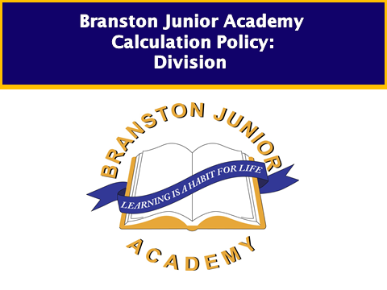

**Children working pre KS1 and entering year 1**

Children will experience equal groups of objects and will count in 2s, 5s and 10s. They will work on practical problem solving activities involving equal sets or groups,

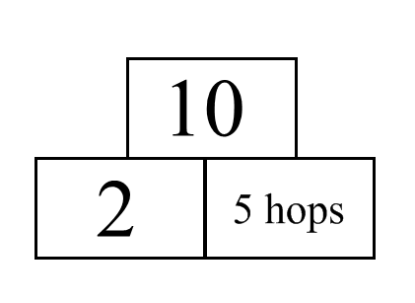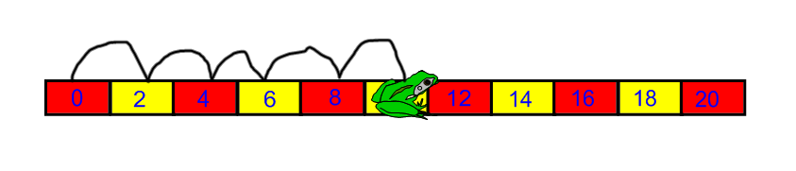

e.g. If the frog hops in 2s, how many hops will there be before he lands on 10?

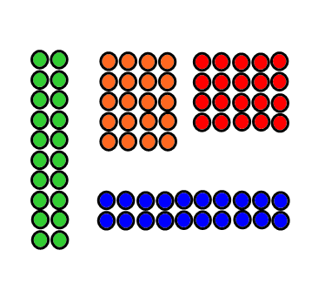

Here are 20 counters. Arrange them in equal rows. Is there a different way to arrange them in equal rows?

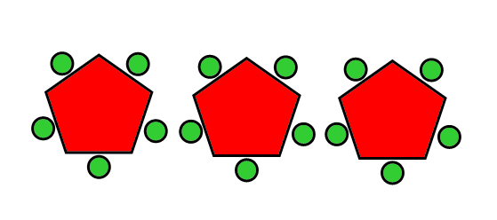*15 children sit at 3 tables. There is the same number of children at each table. How many children sit at each table?*

|  |  |
| --- | --- |
| 🚺    ⚫ ⚫ ⚫ | 🚺  ⚫ ⚫ ⚫ |

Millie had 6 toffees, she gave half to her friend. How many toffees do they each get?

**Children working at year 1**

Children will develop their understanding of multiplication and use jottings to support calculation:

* **Sharing equally**

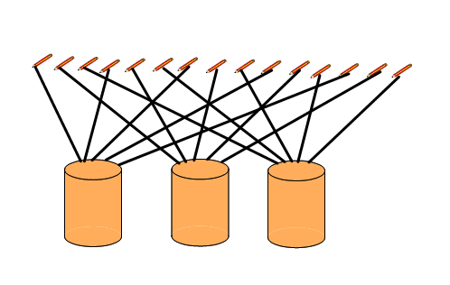

Use **sharing** to answer division questions; Suppose 15 pencils were to be shared out between three children. How many pencils would each child get? Explain to me how you could work it out.

Experience divisions that give rise to remainders, such as:

*Three friends share 16 marbles equally. How many marbles does each friend get? How many marbles are left over?*

* **Grouping or repeated subtraction**

Use practical equipment or objects to answer questions such as: *How many 2s make 12?* Relate this to the division 12 divided by2.

Use objects or a number line to support, record or explain this.

For example, starting from 12, jump back in steps of 2, or starting with 12 counters, keep on taking away 2 counters.

Record this as **repeated subtraction** and as **division**:

12 - 2 - 2 - 2 - 2 - 2 - 2 equals0  
12 divided by2 equals6  
12 divided by 2 equals 6

Children explain how they use equipment, objects or a number line to carry out division.

Or count forward, e.g. How many tens make 80?

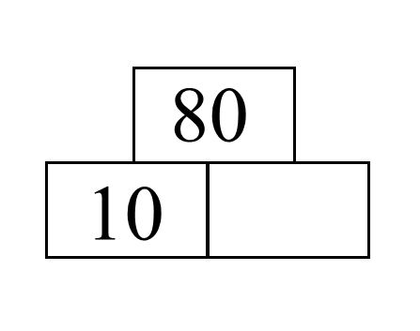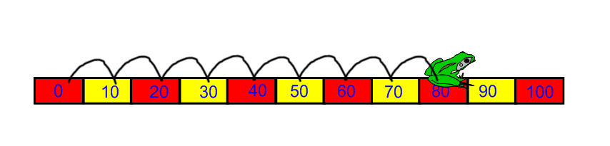

* **Repeated subtraction using a number line or bead bar**

Show me on a number line how you could do: 12 ÷ 3 = 4

0 1 2 3 4 5 6 7 8 9 10 11 12

3 3 3 3

The bead bar will help children with interpreting division calculations such as 12 ÷ 3 as ‘how many 3s make 12?’

* **Using symbols to stand for unknown numbers to complete equations using inverse operations**

|  |  |  |
| --- | --- | --- |
| □ ÷ 2 = 4 | 20 ÷ △ = 4 | □ ÷ △ = 4 |
| A number of marbles divided between 2 groups gives each group 4 each | 20p is divided between some children. Each child gets 4p. How many children are there? | On a number line, I do four equal jumps. What numbers could I land on? |
|  |  |  |
|  |  |  |

**Children working at year 3**

* **Sharing**

Children **understand** **division as sharing**. They solve problems such as:

* *42 crayons are divided equally between six pots. How many crayons are there in each pot?*
* *Three children want to buy their grandmother a present costing pound1.50. They each give the same amount. How much does each child give?*
* *An 80 cm length of ribbon is cut into four equal pieces. How long is each piece?*
* **Repeated subtraction**

Children review **multiplication as repeated addition** and **division as repeated subtraction** by counting hops on a number line. For example, they find how many fours make 24, either by counting on or back 6 hops of 4.

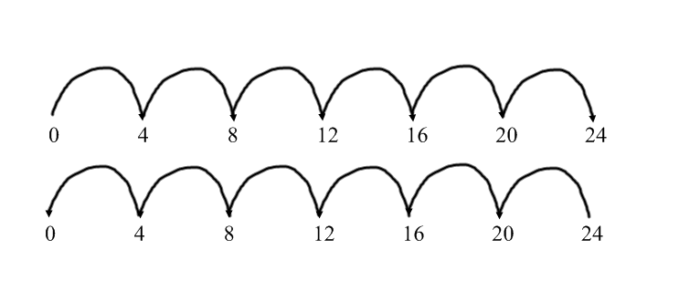

**Children divide a number of objects by using grouping** . They understand that one way to find 30divided by6 is to find how many sixes there are in 30 *.* Through practical experience, they understand that some division calculations have a remainder, for example 13divided by4equals3 R 1:

3 sets of 4 strawberries with one remainder and a number line with 0, 1, 5, 9, 13 showing counting on in fours

[Grouping ITP](http://branston-junior.lincs.sch.uk/media/saturn/grouping_1_2.exe) may be a useful resource

Children **understand the relationship between multiplication and division** . For example, they state two multiplication sentences and two division sentences that relate to a particular array, for example: [Multiarray ITP](http://branston-junior.lincs.sch.uk/media/saturn/multiarray_05.exe)

A two column by five row grid

5multiplied by2equals10, 2multiplied by5equals10  
 10divided by2equals5, 10divided by5equals2

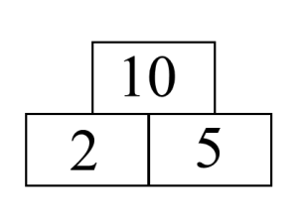They use the image of an array to explain why, for example, 2multiplied by5 gives the same answer as 5multiplied by2. They also use the image to show how many fives make 10 and how many twos make 10.

Children should use number lines or bead bars to support their understanding.

6

6

6

6

0 6 12 18 24

6

6

6

6

Remainders

Children work out calculations that divide exactly and those that give rise to **remainders**. They discuss the images in the [ITP 'Remainders'](http://branston-junior.lincs.sch.uk/media/saturn/remainders_05.exe).

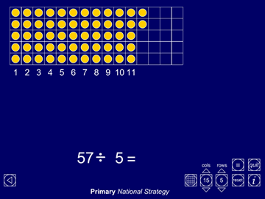

Children **decide whether to round up or down** to answer word problems such as:

* *We have 21 building block wheels. How many four-wheeled cars can we make?*
* *Peaches come in packs of six. I want 20 peaches. How many packs do I need to buy?*
* *How many 30 cm lengths of ribbon can I cut from a ribbon measuring 2 metres?*

Children model such problems with objects or draw a sketch to help them. They discuss their answers and give reasons why they decided to round up or down.

* **Using symbols to stand for unknown numbers to complete equations using inverse operations**

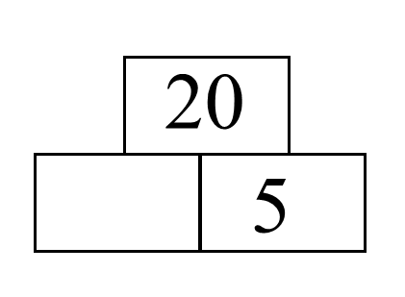 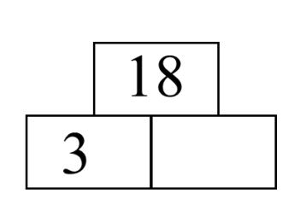 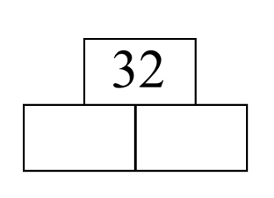

□ x 5 = 20 3 x △ = 18 □ x 🞅 = 32

20 ÷ 5 = □ 18 ÷ 3 = △ 32 ÷ 🞅 = □

complete this division

in as may ways as you can.

**Children working at year 4**

Children will develop their use of repeated subtraction to be able to subtract multiples of the divisor. Initially, these should be multiples of 10s, 5s, 2s and 1s – numbers with which the children are more familiar.

72 ÷ 5

-2 -5 -5 -5 -5 -5 -5 -5 -5 -5 -5 -5 -5 -5 -5

0 2 7 12 17 22 27 32 37 42 47 52 57 62 67 72

Moving onto:

-50

-5

-5

-5

-5

-2

_______________________________________________________

1

1

1

1

10

0 2 7 12 17 22 72

or counting forward(linked to multiplication)

* Solve: 72 ÷ 5 using jumps on a number line

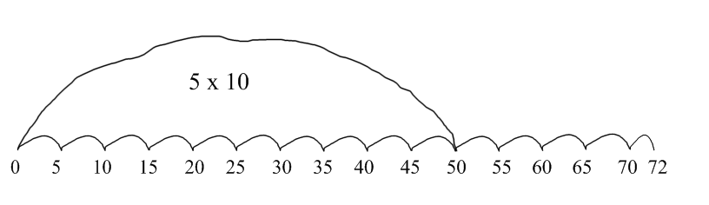

or

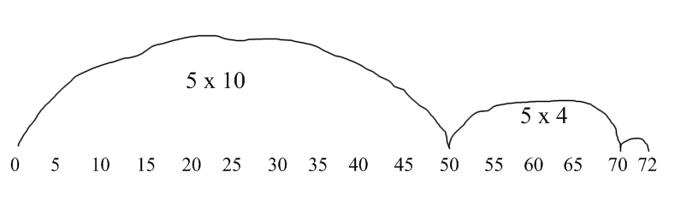

**Leading to mental division using partitioning**

Informal recording in Year 4 for 84 ÷ 7 might be:

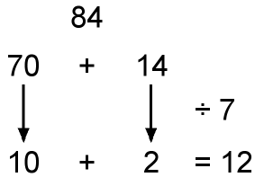

In this example, using knowledge of multiples, the 84 is partitioned into 70 (the highest multiple of 7 that is also a multiple of 10 and less than 84) plus 14 and then each part is divided separately using the distributive law.

Another way to record is in a grid, with links to the grid method of multiplication.

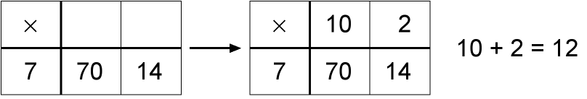

As the mental method is recorded, ask: ‘How many sevens in seventy?’ and: ‘How many sevens in fourteen?’

Could also be recorded vertically, for example:

When dividing 64 by 4 children approximate first. They recognise that the answer must lie between 40 divided by4 equals10 and 80 divided by4 equals20, and use this approximation to do a calculation such as:

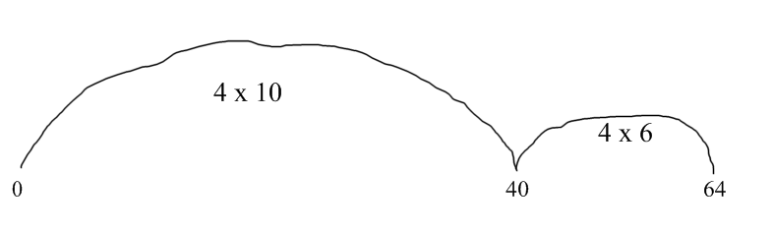

1. ÷ 4 = 16
2. (4 x 10)
3. (4 x 6)

And similarly for remainders

72 ÷5

50 (5x10)

20 (5x4)

2

14r2

**Children working at year 5**

* **Use understanding of place value to multiply and divide whole numbers and decimals by 10, 100 or 1000**

Use calculators (possibly by setting a constant function) or the [ITP 'Moving digits'](http://branston-junior.lincs.sch.uk/media/saturn/moving_digits_06.exe) to explore the effect of repeatedly multiplying/dividing numbers by 10.

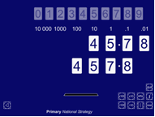

Answer questions such as:

* 32 500 divided byitalic squareequals325
* *How many* pound*10 notes would you need to make* pound*12 000?*
* *Find the missing number in 0.42* multiplied byitalic squareequals*42.*
* *Play 'Stepping stones': Work out what operation to enter into a calculator to turn the number in one stepping stone into the number in the next stepping stone.*

A sequence of stepping stones with the following numbers inside them 3.4, 0.34, 34, 3400, 3.4

* **use and discuss mental strategies** **for special cases of harder types of calculations, for example to work out**
  + using factors

e.g. 90 ÷6 360 ÷5 £2.48 ÷4

90 ÷ 3 ÷ 2 360 ÷10 x2 £2.48 ÷2 ÷2

(90 ÷ 3) ÷ 2 (360 ÷10) x2 (£2.48 ÷2) ÷2

30 ÷ 2 36 x 2 £1.24 ÷2

Ans: 15 Ans: 72 Ans: 62p

* **Refine and use efficient written methods to multiply and divide HTU multiplied byU, TU multiplied byTU, U.t multiplied byU and HTU divided byU**

|  |  |
| --- | --- |
| **Short division of TU ÷ U**  For 81 ÷ 3, the dividend of 81 is split into 60, the highest multiple of 3 that is also a multiple 10 and less than 81, to give 60 + 21. Each number is then divided by 3.  81 ÷ 3  60 (3x20)  21 (3x7)  ans=27  This is then shortened to:    The carry digit ‘2’ represents the 2 tens that have been exchanged for 20 ones. In the first recording above it is written in front of the 1 to show that 21 is to be divided by 3. In second it is written as a superscript.  The 27 written above the line represents the answer: 20 + 7, or 2 tens and 7 ones. | |
|  |  |
| To find 196 ÷ 6, start by multiplying 6 by 10, 20, 30, … to find that 6 × 30 = 180 and 6 × 40 = 240. The multiples of 180 and 240 trap the number 196. This tells us that the answer to 196 ÷ 6 is between 30 and 40.  Start the division by first subtracting 180, leaving 16, and then subtracting the largest possible multiple of 6, which is 12, leaving 4.    The quotient 32 (with a remainder of 4) lies between 30 and 40, as predicted. | |

**Children working at year 6**

* **Calculate mentally with integers and decimals: U.t** plus over minus**U.t, TU** multiplied by**U, TU** divided by**U, U.t** multiplied by**U, U.t** divided by**U;**

|  |  |
| --- | --- |
| Use the fact that 96 divided by6 = 16  to solve 9.6 divided by6 = ∆  or 9.6 divided by 0.6 = ∆ | Calculate 3600 divided by25  (3600 divided by100) x2 x2  (36 x2) x2  72 x2  Ans: 144 |
| *84* divided by6  60 6x10   1. 6x4   Ans: 14 | 9.5 divided by5  95 divided by5 =19  so 9.5 divided by5=1.9 |

|  |  |
| --- | --- |
| **Short division of HTU ÷ U**    The carry digit ‘2’ represents the 2 tens that have been exchanged for 20 ones. In the first recording above it is written in front of the 1 to show that a total of 21 ones are to be divided by 3.  The 97 written above the line represents the answer: 90 + 7, or 9 tens and 7 ones. | |
| A ribbon is 87.6m long. It is cut into 6 eqaul pieces. How long is each piece? Start by multiplying 6 by multiples of 10 to get an estimate. As 6 × 10 = 60 and 6 × 20 = 120, we know the answer lies between 10 and 20 packs. We start by subtracting 60 from 87.6   |  |  |  | | --- | --- | --- | | 6 | 87.6 |  | |  | 60.0 | 6 x10 | |  | 27.6 |  | |  | 24.0 | 6 x4 | |  | 3.6 |  | |  | 3.6 | 6 x0.6 | |  | Ans: | 14.6m | | How many packs of 24 can we make from 560 biscuits? Start by multiplying 24 by multiples of 10 to get an estimate. As 24 × 20 = 480 and 24 × 30 = 720, we know the answer lies between 20 and 30 packs. We start by subtracting 480 from 560.    so 23 packs of 24 biscuits can be made. |
| In effect, the recording above is the long division method, though conventionally the digits of the answer are recorded above the line as shown below. | |

* **Use efficient written methods to add and subtract integers and decimals, to multiply and divide integers and decimals by a one-digit integer, and to multiply two-digit and three-digit integers by a two-digit integer**
* **Solve'missing-number' problems, using their knowledge of inverse operations:**

Link to earlier trio work, e.g.

*50 ÷∆= 2.5* 

