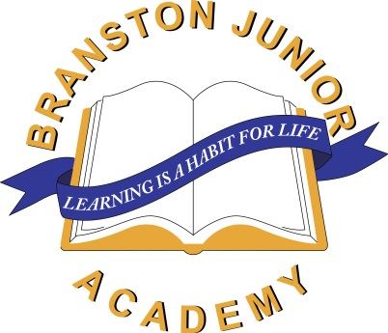[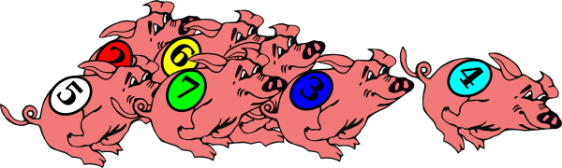](http://www.google.co.uk/url?sa=i&rct=j&q=&esrc=s&source=images&cd=&cad=rja&uact=8&ved=0ahUKEwjBnMWSvPLUAhUESRoKHSaOAGwQjRwIBw&url=http://www.clker.com/clipart-racing-pigs.html&psig=AFQjCNGF2BHxCZNUiAj4CHOejnB_o_QcWQ&ust=1499355327853315)

Saturday 30th September 2017

6-8pm

Tickets cost £1.00 per person – on sale from Branston Junior Academy (Under 5’s free!)

Children MUST be accompanied by an adult.

Bar, tea, coffee,

refreshments on sale.

**pig racing !!**

Branston Junior Academy

01522 880555

[enquiries@branstonjunioracademy.co.uk](mailto:enquiries@branstonjunioracademy.co.uk)

[www.branstonjunioracademy.co.uk](http://www.branstonjunioracademy.co.uk)

@BranstonJunior

Come and join in the family fun…betting on the winning pig for each race!

All funds raised will be going towards purchasing lockers

for the children to use at Branston Junior Academy