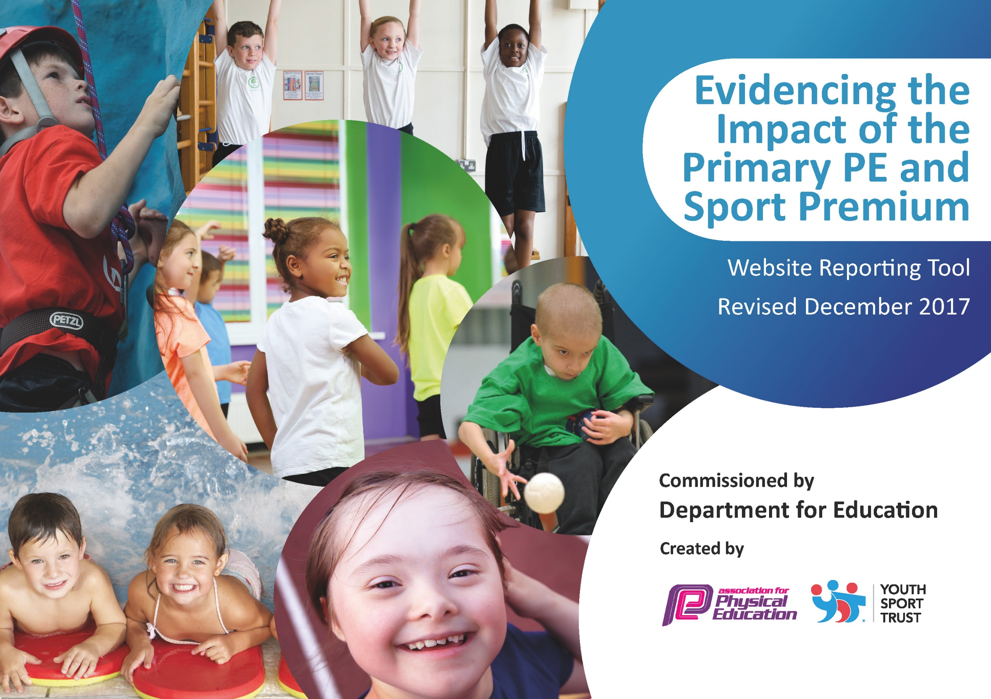

Schools must use the funding to make additional and sustainable improvements to the quality of PE and sport they offer. This means that you should use the Primary PE and Sport Premium to:

- develop or add to the PE and sport activities that your school already offers
- build capacity and capability within the school to ensure that improvements made now will benefit pupils joining the school in future years

Please visit gov.uk for the revised DfE guidance including the 5 key indicators across which schools should demonstrate an improvement. This document will help you to review your provision and to report your spend. DfE encourages schools to use this template as an effective way of meeting the reporting requirements of the Primary PE and Sport Premium.

We recommend you start by reflecting on the impact of current provision and reviewing the previous spend.
Under the Ofsted Schools Inspection Framework, inspectors will assess how effectively leaders use
the Primary PE and Sport Premium and measure its impact on outcomes for pupils, and how effectively governors hold them to account
for this.

Schools are required to publish details of how they spend this funding as well as on the impact it has on pupils’ PE
and sport participation and attainment.
We recommend regularly updating the table and
publishing it on your website as evidence
of your ongoing review into how you are using the money
to secure maximum, sustainable impact. To see an example of how to complete the table please click HERE.

Support for review and reflection - considering the 5 key indicators from DfE, what development needs are a priority for your setting and your students now and why? Use the space below to reflect on previous spend, identify current need and priorities for the future.
Key achievements to date: | Areas for further improvement and baseline evidence of need:
Through the appointment of a specialized PE Coach, lesson plans and resources have been written and created in accordance with the PE National Curriculum, in order that teachers with less experience in planning and delivering PE have the support of accurate resources to aid them.  Due to last years’ expenditure on the promotion of competitive sport, the school has achieved continued excellence and better results across a wide-range of sporting activities.  Promoting an initiative during afternoon lessons reflecting the national ‘Mile a Day’ campaign which has had a significant impact on the children’s cardio vascular fitness. | A carry forward of spend from last year has meant that we can plan to  provide more specialized equipment for the outdoor area which will promote fitness during lesson and during children’s break times. Due to tight deadlines with the provision of the equipment, the money could not be spent during the last financial year therefore £5000 was carried forward and is included within this report.  Continued participation in traditional PE activities and tournaments as well as education and participation in a broader and more unusual range of sporting activities such as curling.

Meeting national curriculum requirements for swimming and water safety | Please complete all of the below*:
What percentage of your current Year 6 cohort swim competently, confidently and proficiently over a distance of at least 25 metres? | 73%
What percentage of your current Year 6 cohort use a range of strokes effectively [for example, front crawl, backstroke and breaststroke]? | 68%
What percentage of your current Year 6 cohort perform safe self-rescue in different water-based situations? | 81%
Schools can choose to use the Primary PE and Sport Premium to provide additional provision for swimming but this must be for activity over and above the national curriculum requirements. Have you used it in this way? | Yes/No No
*Schools may wish to provide this information in April, just before the publication deadline.

Action Plan and Budget Tracking
Capture your intended annual spend against the 5 key indicators. Clarify the success criteria and evidence of impact that you intend to measure to evaluate for students today and for the future.

Academic Year: 2017/18 | Total fund allocated: £ 10, 144 plus  £5000 carried forward from 2016/17 | Date Updated: 28th March 2018
Key indicator 1: The engagement of all pupils in regular physical activity – Chief Medical Officer guidelines recommend that primary school children undertake at least 30 minutes of physical activity a day in school |  |  |  | Percentage of total allocation:
 |  |  |  | 68%
School focus with clarity on intended impact on pupils: | Actions to achieve: | Funding allocated: | Evidence and impact: | Sustainability and suggested next steps:
To purchase outdoor gymnasium  Equipment for the playground.  Impact: Children will have regular access, in lesson time and during free time, to structure sports equipment. | Quotes form specialized sports equipment companies.  Ensuring that plans for installation and use are compliant with installation and use.  Train G&T PE children how to safely use this equipment and how to train others in order to filter this across the whole school.  Ensure all children are aware of the rules for example – only to be used under adult supervision. | £10,235.00 | This equipment is available to use all year round (weather dependent). It is in constant use during the children’s free time (break and lunch times) and has been used as part of outdoor circuit training in PE lessons.  It has provided increased prolonged physical activity and cardio vascular workouts. | Ensure equipment is used in the correct way under adult supervision.  Ensure regular checks on the condition and maintenance of equipment to ensure it complies with H&S regulations.  Ensure of it’s continued use during structure PE lessons as well as the children’s free time.
Key indicator 2: The profile of PE and sport being raised across the school as a tool for whole school improvement |  |  |  | Percentage of total allocation:
 |  |  |  | 3.3%
School focus with clarity on intended impact on pupils: | Actions to achieve: | Funding allocated: | Evidence and impact: | Sustainability and suggested next steps:
We have purchased the following new PE equipment:  football goals - £264.00  netball posts - £203.44  netball nets - £2.53  cones - £30.00  Prior to purchase, children were using netball posts that were the incorrect height and could not be adjusted and sub-standard football nets i.e. large holes in the netting. | Quotes from companies in order the best price for high quality equipment.  Add to the PE stores inventory.  Train Y6 PE monitors to look after the equipment in accordance with H&S regulations. | See Column  1. | Sports teams (netball and football) have been able to practiced using the correct equipment, which compliant with sporting regulations for children of their age (e.g. netball posts at the correct height) and we have been able to hosts visiting schools in these sports.  During PE lessons, children have been able to use the equipment in learning how to play these particular sports. | Ensure equipment is used, transported and stored correctly in order that it does not get damaged and to preserve its lifespan so that it can be used and enjoyed by future cohorts of the school.

Key indicator 3: Increased confidence, knowledge and skills of all staff in teaching PE and sport |  |  |  | Percentage of total allocation:
 |  |  |  | 1.1%
School focus with clarity on intended  impact on pupils: | Actions to achieve: | Funding  allocated: | Evidence and impact: | Sustainability and suggested  next steps:
Two members to attend a PE sports conference in order learn about the current PE focuses within the national curriculum which can be disseminated to the rest of the school teaching staff.  High quality and up to date delivery of the PE curriculum. | Select most suitable staff to maximize impact, those to be delivering the PE curriculum most regularly and with the confidence to train other members of staff.  Book suitable cover to release staff. | £170.00 | Members of staff upskilled in delivery of high quality PE lessons. | Ensure training and knowledge is filtered through to all staff during staff meeting time and training days.  PE lesson observations to ensure continuance of high quality up to date lessons.
Key indicator 4: Broader experience of a range of sports and activities offered to all pupils |  |  |  | Percentage of total allocation:
 |  |  |  | 4.7%
School focus with clarity on intended  impact on pupils: | Actions to achieve: | Funding  allocated: | Evidence and impact: | Sustainability and suggested  next steps:
Additional achievements:  One member of staff to take school sports leaders on ‘Legacy Challenge’ training. A nation-wide sports initiative to improve children’s health and fitness knowledge and activity - .£70.00  Summer Sports and Football Club - £638.00. All children will have the opportunity to access high quality additional sport outside of the national curriculum. | Sports Leaders (selected Year 6 children) to then disseminate information and coordinate across whole school.  Employ a qualified Sports Coach (Jim Gillespie) to provide additional after-school clubs. | £708.00 | Children will take part in the term during the Summer Term 2018.  27 chn joined the football club in order to improve existing knowledge and football skills. | Monitoring outcome – how many children completed the challenge? Has improved fitness/interest in fitness across the school?  Monitor attendance of the club and continue to promote the club to all children who show an interest in these sports.
Key indicator 5: Increased participation in competitive sport |  |  |  | Percentage of total allocation:
 |  |  |  | 8.3%
School focus with clarity on intended  impact on pupils: | Actions to achieve: | Funding  allocated: | Evidence and impact: | Sustainability and suggested  next steps:
Children across all year groups were given the opportunity to take part in a wide-range of inter-school competitions and tournaments:  - Swimming  - Rounders  - Multi-Sports  - Football  - Hockey  Opportunity to experience competitive sports and to learn good sportsmanship.  Sports tournaments and transport – £1228.63  Netball League Fees - £25.00 | Selecting participants, parental permission in accordance with school policy, book appropriate means of transport/parent volunteers to transport (in line with school policy). Preparing the children in the art of sportsmanship and fair competition. | £1253.63 | Have achieved outstanding results across all of the competitions including winning a ‘fair play’ award at one of the football tournaments.  BJA has a reputation around the local schools for excellence in sport and we have been able to promote this in a number of the local publications, the school website and school social media. | Continue to enter and promote participation in inter-school sports competition.  Use future PE premium funding to renew the dated and dwindling supply of school sports kit.  Keep and maintain a register of who has been issued and returned the kit.  Allocate a portion of the budget to hosting visiting teams by provision of refreshment (juice and biscuits).

